Nam Nguyen

npn190000

**Exercises**

**Section 5.2: 1, 2, 4, 9, 17(c,d)**

1. What is the numerical value of the composite trapezoid rule applied to the reciprocal function f (x) = x−1 using the points 1, 4/ 3 , and 2?

Answer:

function f (x) = x−1

f(1) = 1; f(4/3) = ¾; f(2) = ½

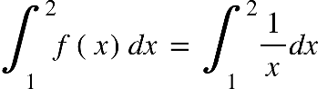

Trapezoid rule at point 1, 4/3

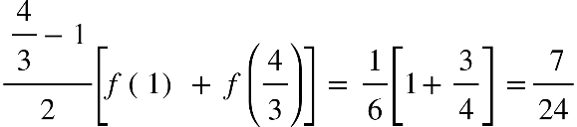

Trapezoid rule at point 4/3,2

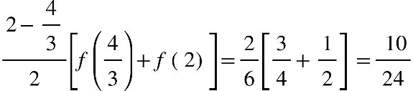

Total:

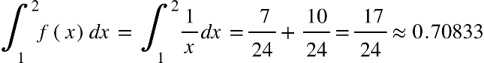

2. Compute an approximate value of 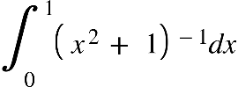 by using the composite trapezoid rule with three points. Then compare with the actual value of the integral. Next, determine the error formula and numerically verify an upper bound on it.

Answer:

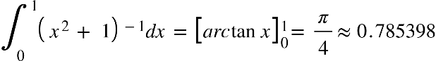

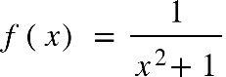

f(0) = 1; f(1/2) = 4/5; f(1) = ½

Trapezoid rule at point 0, 1/2

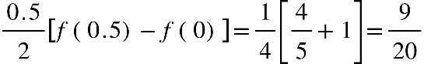

Trapezoid rule at point 1/2 ,1

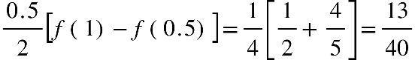

Total

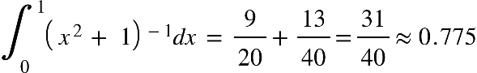

**The required error**: 0.785398 – 0.775 ~ 0.010398

vertical line E subscript T vertical line less or equal than fraction numerator K open parentheses b minus a close parentheses cubed over denominator 12 n squared end fraction space w i t h space n space equals 2
K equals vertical line f apostrophe apostrophe open parentheses x close parentheses vertical line space m a x i m u m space v a l u e space o f space f open parentheses x close parentheses space o n space open square brackets 0 comma 1 close square brackets

f open parentheses x close parentheses equals open parentheses x squared plus 1 close parentheses to the power of negative 1 end exponent
f apostrophe open parentheses x close parentheses equals space minus 1 open parentheses x squared plus 1 close parentheses to the power of negative 2 end exponent times 2 n equals negative 2 x open parentheses x squared plus 1 close parentheses to the power of negative 2 end exponent
f apostrophe apostrophe open parentheses x close parentheses equals space minus 2 open parentheses x squared plus 1 close parentheses to the power of negative 2 end exponent plus 4 x open parentheses x squared plus 1 close parentheses to the power of negative 3 end exponent
equals fraction numerator 6 x squared minus 2 over denominator open parentheses x squared plus 1 close parentheses cubed end fraction


|f’’(1)| = 0.5

|f’’(0)|= 2

|f’’(x)| maximum at x=0 belong [0,1]

vertical line E subscript T vertical line less or equal than fraction numerator 2 open parentheses 1 minus 0 close parentheses cubed over denominator 12 times 2 squared end fraction
vertical line E subscript T vertical line less or equal than 2 over 48 almost equal to 0.0416


**Upper bound is** 0.0416

4. Obtain an upper bound on the absolute error when we compute 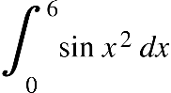 by means of the composite trapezoid rule using 101 equally spaced points.

Answer:

f(x) = sin x2

f’(x) = 2x cos x2

f’’(x)= 2 cos x2 + 4x2 sin x2

Triangle inequality:

|f’’(x)| = |2 cos x2 + 4x2 sin x2| ≤ 2| cos x2 |+ 4|x2 sin x2| < 2 + 4(36) = 146

|I-T|= 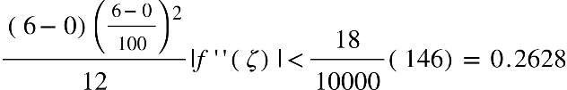

Hence, upper bound is 0.2628.

9. Prove that if a function is concave downward, then the trapezoid rule underestimates the integral.

Answer:

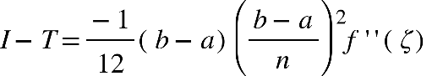

Concave downward, Therefore, the error is positive

≥ 0. Hence I ≥ T, then the trapezoid rule underestimates the integral.

17. Consider the integral I(h) ≡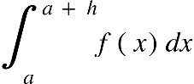. Establish an expression for the error term for each of the following rules:

c. I(h) ≈ h f (a) d. I(h) ≈ h f (a) – 1/2 h2 f’ (a)

For each, determine the corresponding general rule and error terms for the integral 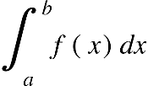, where the partition is uniform; that is, xi = a + ih and h = (b − a)/n for 0 ≤ i ≤n

Answer:

I(h) ≡.

Consider the series of f(x) with variation t:

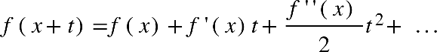

c. I(h) ≈ h f (a)

integral subscript a superscript a space plus space h end superscript f open parentheses x close parentheses d x equals space integral subscript 0 superscript h f open parentheses a plus t close parentheses d t equals integral subscript 0 superscript h open square brackets f open parentheses a close parentheses plus space f apostrophe open parentheses a close parentheses t plus fraction numerator f apostrophe apostrophe open parentheses a close parentheses over denominator 2 end fraction t squared plus... close square brackets d t
equals space open square brackets f open parentheses a close parentheses t space plus f apostrophe open parentheses a close parentheses t squared over 2 plus f apostrophe apostrophe open parentheses a close parentheses t cubed over 6 close square brackets subscript 0 superscript h equals h f open parentheses a close parentheses plus f apostrophe open parentheses zeta close parentheses h squared over 2

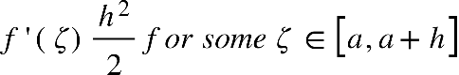

We have extend the rule to any interval [a,b] we can compute

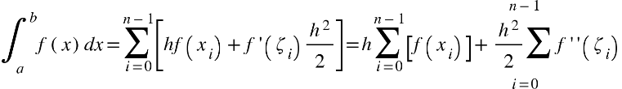

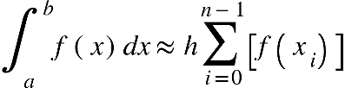

Where h (b-a)/n. This has an error term

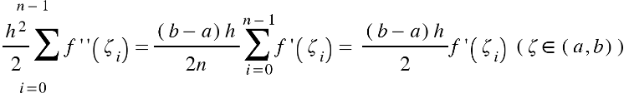

d. I(h) ≈ h f (a) – 1/2 h2 f’ (a)

integral subscript a superscript a space plus space h end superscript f open parentheses x close parentheses d x equals space integral subscript 0 superscript h f open parentheses a plus t close parentheses d t equals integral subscript 0 superscript h open square brackets f open parentheses a close parentheses plus space f apostrophe open parentheses a close parentheses t plus fraction numerator f apostrophe apostrophe open parentheses a close parentheses over denominator 2 end fraction t squared plus... close square brackets d t
equals space open square brackets f open parentheses a close parentheses t space plus f apostrophe open parentheses a close parentheses t squared over 2 plus f apostrophe apostrophe open parentheses a close parentheses t cubed over 6 close square brackets subscript 0 superscript h equals h f open parentheses a close parentheses plus f apostrophe open parentheses zeta close parentheses h squared over 2



We have extend the rule to any interval [a,b] we can compute

integral subscript a superscript b f open parentheses x close parentheses d x equals sum from i equals 0 to n minus 1 of open square brackets h f open parentheses x subscript i close parentheses plus f apostrophe open parentheses zeta subscript i close parentheses h squared over 2 plus f apostrophe apostrophe open parentheses zeta subscript i close parentheses h cubed over 6 close square brackets
equals open parentheses h sum from i equals 0 to n minus 1 of open square brackets f open parentheses x subscript i close parentheses close square brackets plus stack h squared over 2 sum with i equals 0 below and n minus 1 on top f apostrophe open parentheses zeta subscript i close parentheses close parentheses plus h cubed over 6 sum from i equals 0 to n minus 1 of f apostrophe apostrophe open parentheses zeta subscript i close parentheses

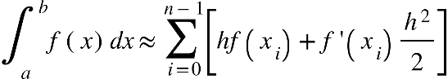

Where h (b-a)/n. This has an error term



**Section 6.1: 1, 2(b,c), 8**

1. Compute 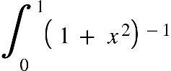 by the basic Simpson’s Rule, using the three partition points x = 0, 0.5, and 1. Compare with the true solution.

Answer:

f(x)= (1 + x2)-1

f(0) = 1; f(0.5) = 0.8; f(1)=0.5

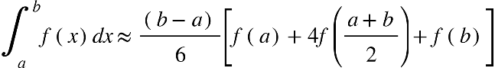



True solution:

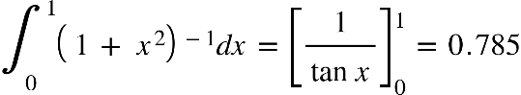

Compare |0.783-0.785|=0.002

2. Consider the integral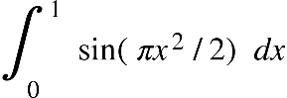. Suppose that we wish to integrate numerically, with an error of magnitude less than 10−3.

b. Composite Simpson’s Rule? c. Composite Simpson’s 38 Rule?

Answer:

a.

E space equals space I space minus space T space equals space fraction numerator negative open parentheses b minus a close parentheses h squared over denominator 12 end fraction f apostrophe apostrophe open parentheses zeta close parentheses space w h e n space zeta space element of open parentheses a comma b close parentheses
vertical line E vertical line space less or equal than space fraction numerator open parentheses b minus a close parentheses h squared over denominator 12 end fraction M space w h e r e space M space equals space f apostrophe apostrophe open parentheses zeta close parentheses space w h e n space zeta space element of open parentheses a comma b close parentheses


triangle inequality

Triangle inequality



vertical line E vertical line space less or equal than space fraction numerator open parentheses b minus a close parentheses h squared over denominator 12 end fraction M space equals fraction numerator 1 times 13.01. h squared over denominator 12 end fraction


Given error of magnitude less than 10−3.

fraction numerator 13.01. h squared over denominator 12 end fraction less or equal than 10 to the power of negative 3 space end exponent minus greater than h squared less or equal than 0.03037 space


b. Composite Simpson’s Rule?

E space equals space I space minus space T space equals space fraction numerator negative open parentheses b minus a close parentheses h to the power of 4 over denominator 180 end fraction f to the power of open parentheses 4 close parentheses end exponent open parentheses zeta close parentheses space w h e n space zeta space element of open parentheses a comma b close parentheses




triangle inequality

vertical line space straight f to the power of open parentheses 4 close parentheses end exponent left parenthesis straight x right parenthesis vertical line equals space vertical line minus 3 straight pi squared space sin open parentheses πx squared over 2 close parentheses minus 6 straight pi cubed straight x cubed cos open parentheses πx squared over 2 close parentheses plus straight pi to the power of 4 straight x to the power of 4 space sin open parentheses πx squared over 2 close parentheses vertical line less or equal than space 3 straight pi squared space vertical line sin open parentheses πx squared over 2 close parentheses vertical line space plus space 6 straight pi cubed vertical line straight x cubed cos open parentheses πx squared over 2 close parentheses vertical line space plus space straight pi to the power of 4 vertical line straight x to the power of 4 space sin open parentheses πx squared over 2 close parentheses vertical line
less or equal than 3 straight pi squared space plus space 6 straight pi cubed space plus space straight pi to the power of 4 space almost equal to 313.06

vertical line E vertical line space less or equal than space fraction numerator open parentheses b minus a close parentheses h to the power of 4 over denominator 180 end fraction M space equals fraction numerator 313.6. h to the power of 4 over denominator 180 end fraction


Given error of magnitude less than 10−3.

fraction numerator 313.6. h to the power of 4 over denominator 180 end fraction less or equal than 10 to the power of negative 3 end exponent space minus greater than space h space less than space 0.1549


c. Composite Simpson’s 38 Rule?

E space equals space I space minus space T subscript 3 over 8 end subscript space equals space fraction numerator negative open parentheses b minus a close parentheses h to the power of 4 over denominator 80 end fraction f to the power of open parentheses 4 close parentheses end exponent open parentheses zeta close parentheses space w h e n space zeta space element of open parentheses a comma b close parentheses


vertical line E vertical line space less or equal than space fraction numerator open parentheses b minus a close parentheses h to the power of 4 over denominator 80 end fraction M space equals fraction numerator 313.6. h to the power of 4 over denominator 80 end fraction


Given error of magnitude less than 10−3.

fraction numerator 313.6. h to the power of 4 over denominator 80 end fraction less or equal than 10 to the power of negative 3 end exponent space minus greater than space h space less than space 0.1264


8. A numerical integration scheme that is not as well known is the basic Simpson’s 3/ 8 Rule over three subintervals:  Establish the error term for this rule, and explain why this rule is overshadowed by Simpson’s Rule.

Answer:



Consider:

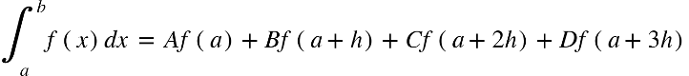

f open parentheses a plus h close parentheses space equals space f open parentheses a close parentheses plus space f apostrophe open parentheses a close parentheses h space plus space f apostrophe apostrophe open parentheses a close parentheses h squared over 2 plus f apostrophe apostrophe apostrophe open parentheses a close parentheses h cubed over 6 plus f to the power of open parentheses 4 close parentheses end exponent open parentheses a close parentheses h to the power of 4 over 24 plus...
f open parentheses a plus 2 h close parentheses space equals space f open parentheses a close parentheses plus 2 space f apostrophe open parentheses a close parentheses h space plus 2 space f apostrophe apostrophe open parentheses a close parentheses h squared plus 4 f apostrophe apostrophe apostrophe open parentheses a close parentheses h cubed over 3 plus 2 f to the power of open parentheses 4 close parentheses end exponent open parentheses a close parentheses h to the power of 4 over 3 plus...
f open parentheses a plus 3 h close parentheses space equals space f open parentheses a close parentheses plus space 3 f apostrophe open parentheses a close parentheses h space plus space 9 f apostrophe apostrophe open parentheses a close parentheses h squared over 2 plus 9 f apostrophe apostrophe apostrophe open parentheses a close parentheses h cubed over 2 plus 27 f to the power of open parentheses 4 close parentheses end exponent open parentheses a close parentheses h to the power of 4 over 8 plus...

We have computed the sum:

left square bracket f left parenthesis a right parenthesis space plus space 3 f left parenthesis a plus h right parenthesis space plus 3 f left parenthesis a plus 2 h right parenthesis plus f left parenthesis a plus 3 h right parenthesis right square bracket equals space
equals space 8 f open parentheses a close parentheses space plus 12 f apostrophe open parentheses a close parentheses h space plus space 12 f apostrophe apostrophe open parentheses a close parentheses h squared space plus space 9 f apostrophe apostrophe apostrophe open parentheses a close parentheses h cubed plus 11 over 2 f to the power of open parentheses 4 close parentheses end exponent open parentheses a close parentheses h to the power of 4 plus...

fraction numerator 3 h over denominator 8 end fraction left square bracket f left parenthesis a right parenthesis space plus space 3 f left parenthesis a plus h right parenthesis space plus 3 f left parenthesis a plus 2 h right parenthesis plus f left parenthesis a plus 3 h right parenthesis right square bracket equals space
equals space 3 f open parentheses a close parentheses h space plus 9 over 2 f apostrophe open parentheses a close parentheses h squared space plus space 9 over 2 f apostrophe apostrophe open parentheses a close parentheses h cubed space plus space 27 over 8 f apostrophe apostrophe apostrophe open parentheses a close parentheses h to the power of 4 plus 33 over 16 f to the power of open parentheses 4 close parentheses end exponent open parentheses a close parentheses h to the power of 5 plus... (1)

We also integrate

integral subscript a superscript a plus 3 h end superscript f open parentheses x close parentheses d x equals integral subscript 0 superscript 3 h end superscript f open parentheses a plus t close parentheses d t space equals space space integral subscript 0 superscript 3 h end superscript open parentheses f open parentheses a close parentheses plus space f apostrophe open parentheses a close parentheses t space plus space f apostrophe apostrophe open parentheses a close parentheses t squared over 2 plus f apostrophe apostrophe apostrophe open parentheses a close parentheses t cubed over 6 plus f to the power of open parentheses 4 close parentheses end exponent open parentheses a close parentheses t to the power of 4 over 24 plus... close parentheses d t space equals
equals open square brackets f open parentheses a close parentheses t plus space f apostrophe open parentheses a close parentheses t squared over 2 space plus space f apostrophe apostrophe open parentheses a close parentheses t cubed over 6 plus f apostrophe apostrophe apostrophe open parentheses a close parentheses t to the power of 4 over 24 plus f to the power of open parentheses 4 close parentheses end exponent open parentheses a close parentheses t to the power of 5 over 120 plus... close square brackets subscript 0 superscript 3 h end superscript equals
equals space 3 h f open parentheses a close parentheses plus space f apostrophe open parentheses a close parentheses fraction numerator 9 h squared over denominator 2 end fraction space plus space f apostrophe apostrophe open parentheses a close parentheses fraction numerator 9 h cubed over denominator 2 end fraction plus f apostrophe apostrophe apostrophe open parentheses a close parentheses fraction numerator 27 h to the power of 4 over denominator 8 end fraction plus f to the power of open parentheses 4 close parentheses end exponent open parentheses a close parentheses fraction numerator 81 h to the power of 5 over denominator 40 end fraction plus...(2)

From (1):

 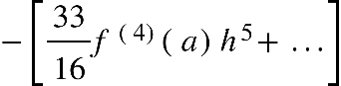

From (2):

integral subscript a superscript a plus 3 h end superscript f open parentheses x close parentheses d x equals open square brackets 3 h f open parentheses a close parentheses plus space f apostrophe open parentheses a close parentheses fraction numerator 9 h squared over denominator 2 end fraction space plus space f apostrophe apostrophe open parentheses a close parentheses fraction numerator 9 h cubed over denominator 2 end fraction plus f apostrophe apostrophe apostrophe open parentheses a close parentheses fraction numerator 27 h to the power of 4 over denominator 8 end fraction close square brackets plus f to the power of open parentheses 4 close parentheses end exponent open parentheses a close parentheses fraction numerator 81 h to the power of 5 over denominator 40 end fraction plus...
equals space 3 h divided by 8 space space left square bracket space f left parenthesis a right parenthesis space plus space 3 f left parenthesis a space plus space h right parenthesis space plus space 3 f left parenthesis a space plus space 2 h right parenthesis space plus space f left parenthesis a space plus space 3 h right parenthesis right square bracket space space minus open square brackets 33 over 16 f to the power of open parentheses 4 close parentheses end exponent open parentheses a close parentheses h to the power of 5 plus space... close square brackets plus f to the power of open parentheses 4 close parentheses end exponent open parentheses a close parentheses fraction numerator 81 h to the power of 5 over denominator 40 end fraction plus... equals



Hence error is 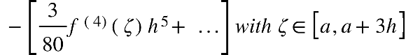. The Simpson’s rule is preferred since it relies only on three function evaluations instead of 4. Also, the evaluation in the 3/8 error remains in the same order.

**Section 6.2: 1, 2b, 5, 8, 9, 11**

1. A Gaussian quadrature rule for the interval [−1, 1] can be used on the interval [a, b] by applying a suitable linear transformation. Approximate

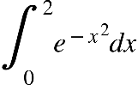

using the transformed rule from Table 6.1 with n = 1.

Answer:

 Let x = y +1 -> dx = dy-> 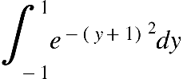

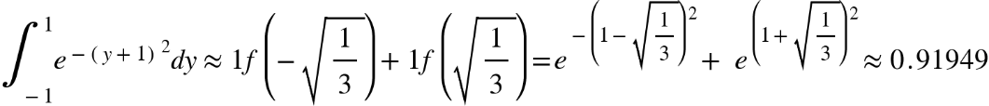

2. Using Table 6.1, show directly that the Gaussian quadrature rule is exact for the polynomials 1, x, x2,..., x2n+1 when

**b**. n = 3

Answer:

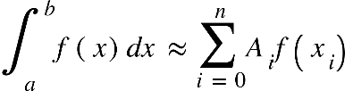

Here, 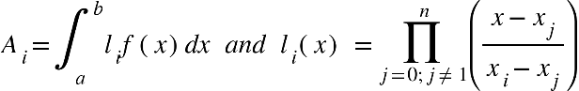

For n =3, nodes are 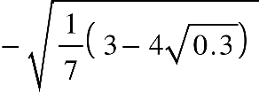,,

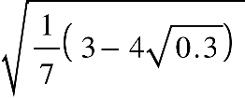,  corresponding weights 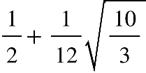, 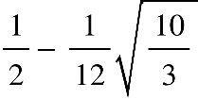,,

f(x) = 1 + x + x2 + x3 + x4 + x5 + x6 + x7



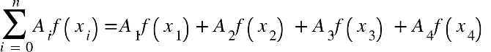

= open parentheses 1 half plus 1 over 12 square root of 10 over 3 end root close parentheses space f open parentheses negative square root of 1 over 7 open parentheses 3 minus 4 square root of 0.3 end root close parentheses end root close parentheses plus
plus open parentheses 1 half minus 1 over 12 square root of 10 over 3 end root close parentheses space f open parentheses negative square root of 1 over 7 open parentheses 3 minus 4 square root of 0.3 end root close parentheses end root close parentheses
plus space open parentheses 1 half plus 1 over 12 square root of 10 over 3 end root close parentheses space f open parentheses square root of 1 over 7 open parentheses 3 minus 4 square root of 0.3 end root close parentheses end root close parentheses
plus space open parentheses 1 half minus 1 over 12 square root of 10 over 3 end root close parentheses space f open parentheses square root of 1 over 7 open parentheses 3 minus 4 square root of 0.3 end root close parentheses end root close parentheses

Therefore, 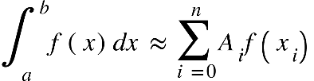 Hence quadratic rule is n = 3.

5. Construct a rule of the form 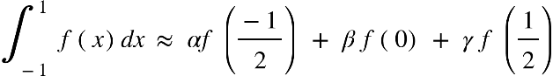 that is exact for all polynomials of degree ≤ 2; that is, determine values for α, β, and γ . Hint: Make the relation exact for 1, x, and x2 and find a solution of the resulting equations. If it is exact for these polynomials, it is exact for all polynomials of degree ≤ 2.

Answer:



8. Derive a formula of the 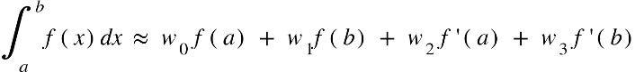 that is exact for polynomials of the highest degree possible.

Answer:

11. Derive a numerical integration formula of the form 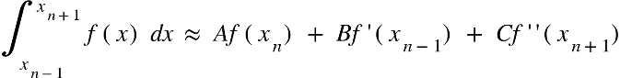

for uniformly spaced points xn−1, xn, and xn+1 with spacing h. The formula should be exact for polynomials of as high a degree as possible. Hint: Consider 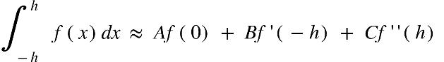

Answer:

**Computing Exercises**

**Section 5.2: 1, 2, 5 ( c )**

1. Write

**real function** Trapezoid Uniform( f, a, b, n) to calculate  using the composite trapezoid rule with n equal subintervals.

Answer:

2. (Continuation) Test the code written in the preceding computer problem on the following functions. In each case, compare with the correct answer.



Answer:

5. Compute these integrals by using small and large values for the lower and upper limits and applying a numerical method. Then compute them by first making the indicated change of variable.

c. 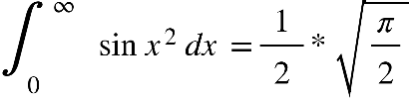, using x = tan t (Fresnel sine integral)

Answer:

**Section 6.1: 1**

1. Find approximate values for the two integrals

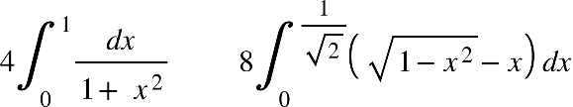

Use recursive function Simpson with ε = 1 /2×10−5 and level max = 4. Sketch the curves of the integrand f (x) in each case, and show how Simpson partitions the intervals. You may want to print the intervals at which new values are added to Simpson result in function Simpson and also to print values of f (x) over the entire interval [a, b] in order to sketch the curves.

Answer:

**Section 6.2: 1, 3, 6**

1. Write a program to evaluate an integral  using Formula (5).

Answer:

3. (Continuation) Compute 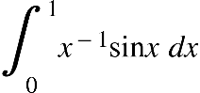 by the Gaussian Formula (5) suitably modified.

Answer:

6. Apply and compare the composite rules for Trapezoid, Midpoint, Two-Point Gaussian, and Simpson’s 1/ 3 Rule for approximating the integral 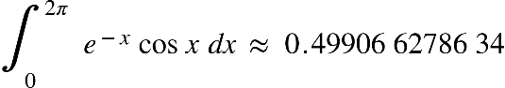

using 32 applications of each basic rule.

Answer: